Install SparkR on AWS EMR

1.log in aws, access fellowing url:
https://us-west-1.console.aws.amazon.com/elasticmapreduce/home?region=us-west-1#cluster-list:

2.Click the button “Create cluster”
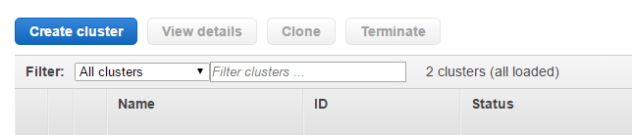

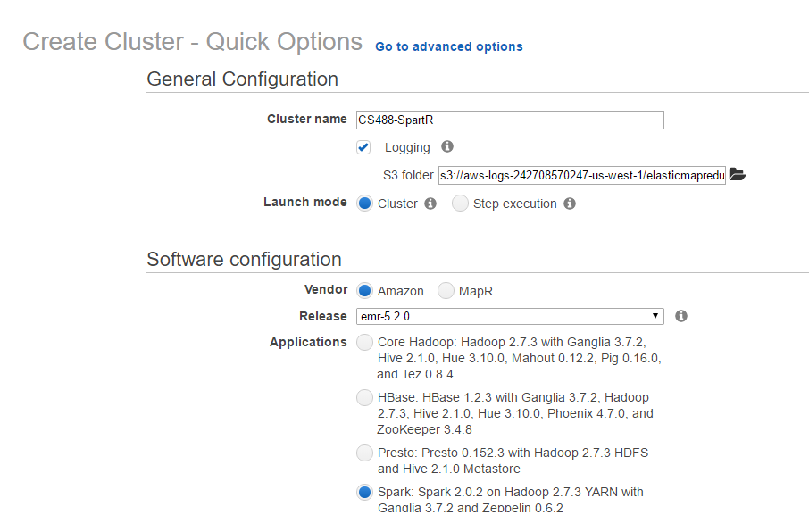
3.Click “Go to advanced options”
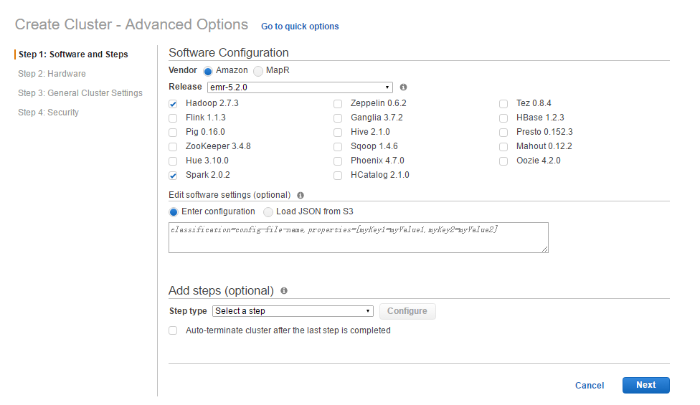
4.select Hadoop and Spark, click “Next” button

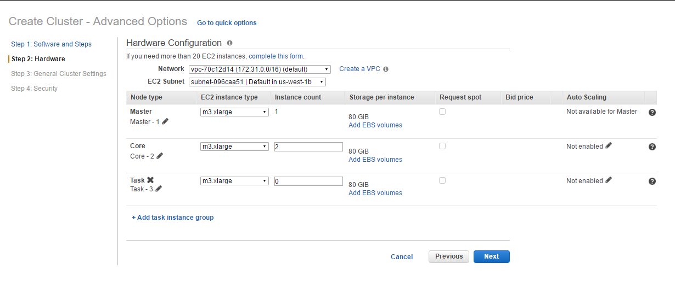

5.use default Hardware,go next
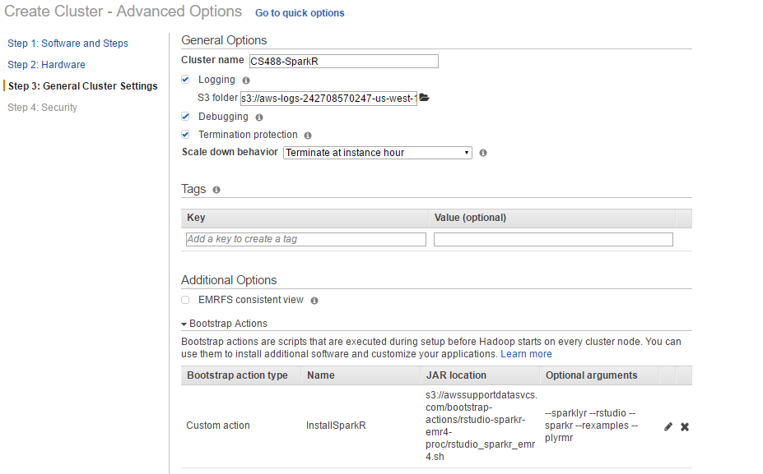
6. Here input Cluster name , the most import thing is add Bootstrap Actions.
Name: InstallSparkR
Script location:
s3://awssupportdatasvcs.com/bootstrap-actions/rstudio-sparkr-emr4-proc/rstudio_sparkr_emr4.sh
Optinal arguments:
--sparklyr --rstudio --sparkr --rexamples --plyrmr
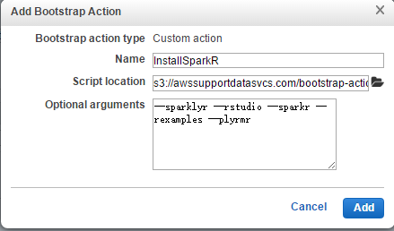

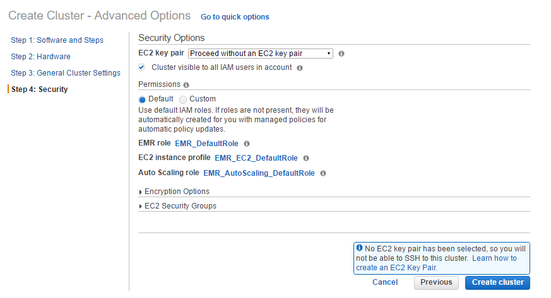
7.Select your key pair,create cluster
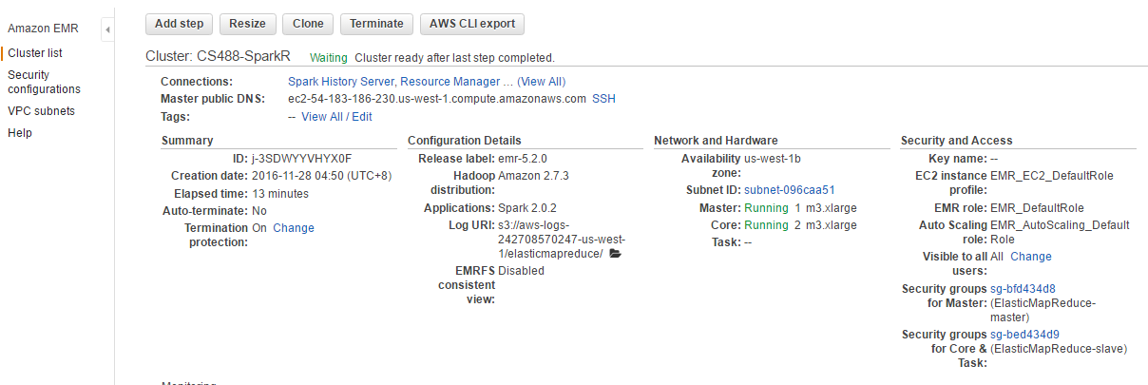

8. http://<EMR master instance>:8787 ,access RStudio
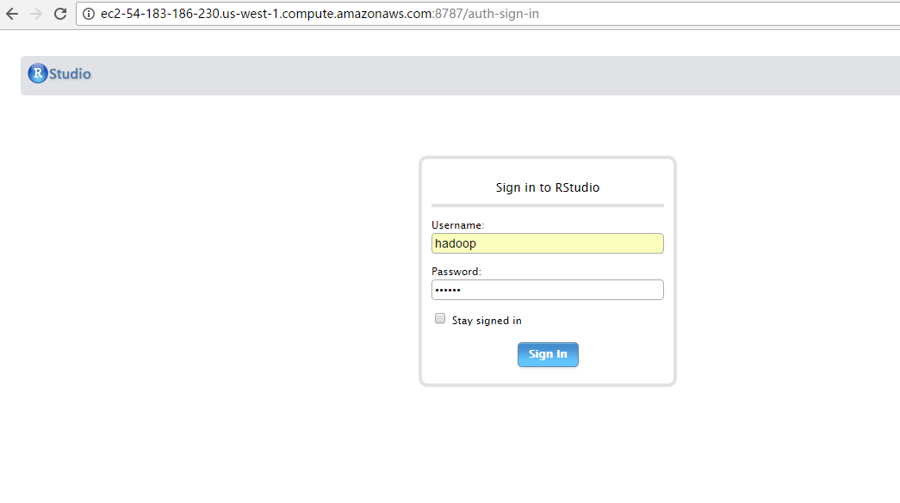
9.name and password: hadoop

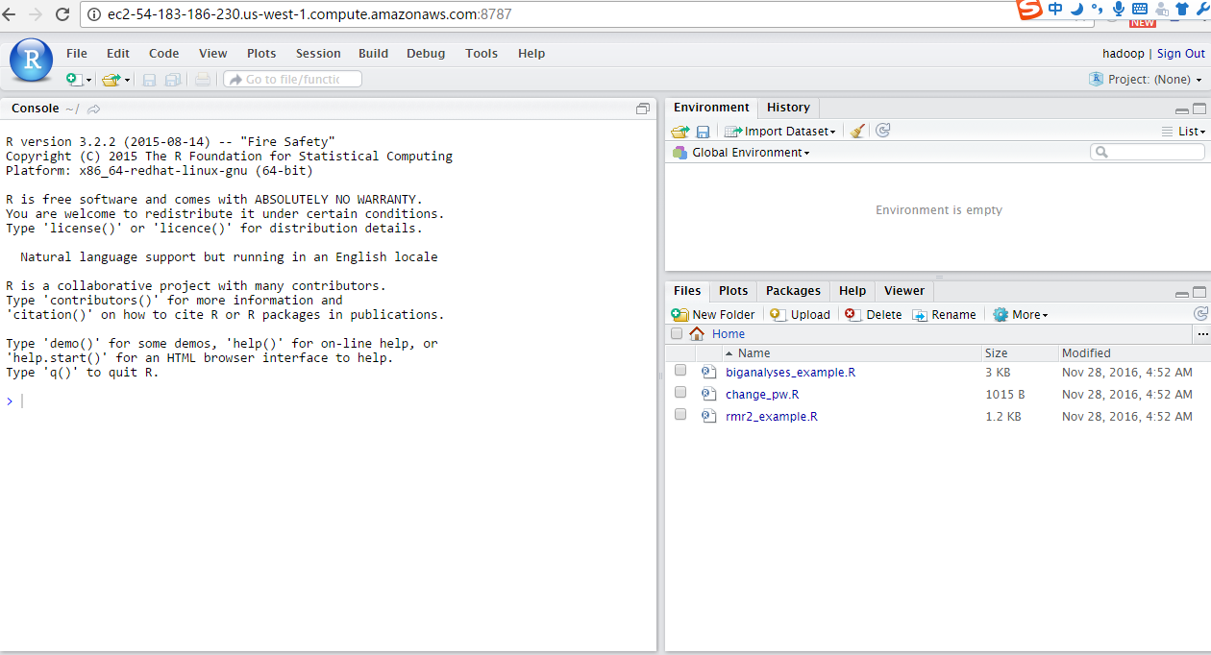
10. Run the R example: rmr2_example.R
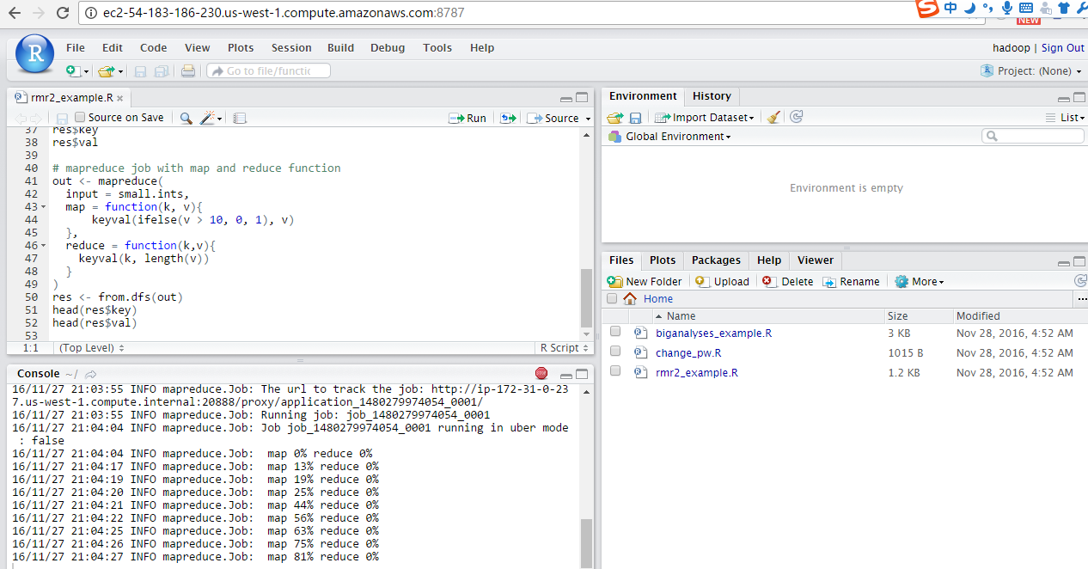
11.we can see the mapreduce process
12.Refference:
https://aws.amazon.com/cn/blogs/big-data/running-sparklyr-rstudios-r-interface-to-spark-on-amazon-emr/

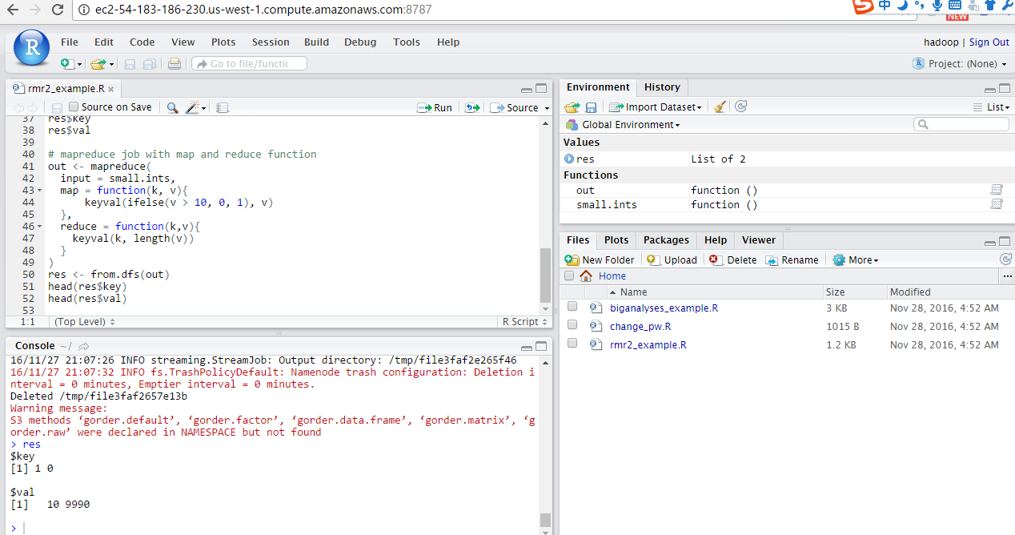
12. Show the result

